St. Leonard Volunteer Fire & Rescue
Presents
Haunted Fire House
Boo-Thru

Come join us for a little Safe & Spooky Halloween fun
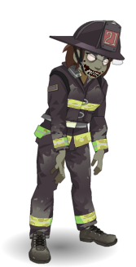
There will also be
Trunk or Treat
on site
Friday October 30th 6pm-9pm

200 Calvert Beach Rd

